

Example Research Proposal

Required Sections:

1. **Introduction:** Provide an overview of the capstone project, its objectives, and its significance in the context of the course. Clearly state the research question or problem that the project aims to address.
2. 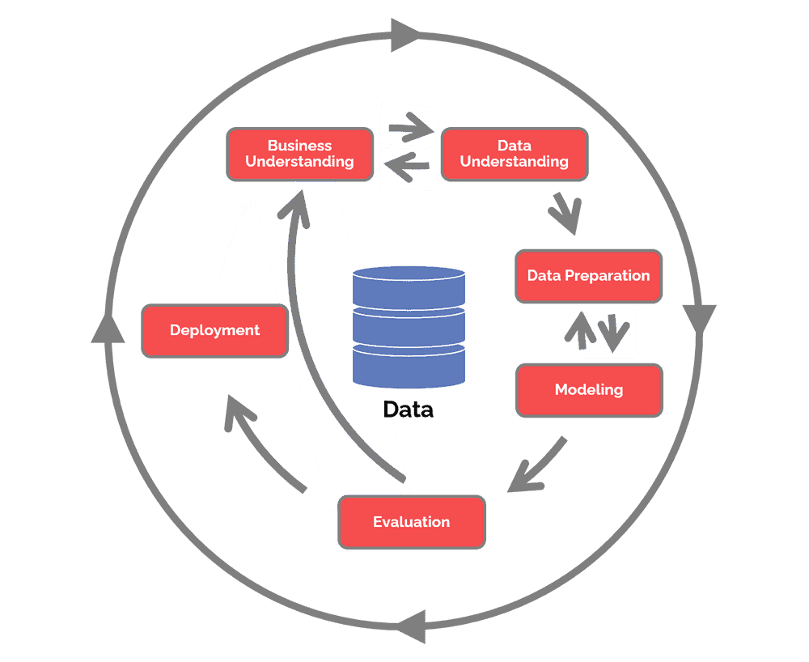**Business Understanding:** Explain the practical relevance and real-world implications of the research question. Describe the domain or industry context, highlighting the importance of understanding the factors influencing the research question.
3. **Data Understanding:** Discuss the dataset selected for analysis, its source, size, and structure. Provide an overview of the variables, their meanings, and any associated metadata. Address potential data quality issues, missing values, or outliers.
4. **Data Preparation:** Outline the steps taken to preprocess and clean the data. Discuss how missing values, outliers, and inconsistent formatting were handled. Describe any feature engineering or variable transformations performed to enhance the dataset for analysis.
5. **Exploratory Data Analysis (EDA):** Present the results of EDA, including visualizations, statistical summaries, and key insights derived from analyzing the dataset. Highlight any patterns, relationships, or trends observed in the data.
6. **Modeling:** Describe the modeling techniques employed to address the research question. Discuss the selection of appropriate models, their advantages, and the rationale behind their choice. Explain how the dataset was split into training and testing sets for model training and evaluation.
7. **Evaluation:** Detail the evaluation metrics used to assess the models' performance and their ability to predict the desired outcomes. Explain the interpretation of the evaluation results and their implications for the research question.
8. **Deployment:** Outline the steps taken to deploy the selected model(s) for practical use. Discuss the considerations related to scalability, efficiency, and integration with other systems. Address documentation, model monitoring, and maintenance practices.
9. **Drawing Conclusions and Results:** Summarize the conclusions drawn from the analysis and modeling stages. Highlight the key findings, their significance, and how they relate to the research question. Discuss the performance of the models and their suitability for addressing the problem.
10. **Documentation and Presentation:** Describe the documentation and presentation materials created to communicate the project's methodology, analysis, and findings. Discuss the project report, visualizations, code documentation, user guide, and stakeholder engagement activities.
11. **Ethical Considerations:** Address any ethical considerations associated with the project, such as data privacy, fairness, and potential biases. Discuss the steps taken to ensure ethical practices throughout the project.

By including these essential sections in the proposal, you will provide a comprehensive overview of the capstone project, its objectives, the data analysis process, the modeling approach, and the intended outcomes. This structure will guide the development and execution of the project while ensuring alignment with the course requirements.

Analyzing Factors Affecting the Survival Rates of Passengers on the Titanic: A Data-Driven Investigation

1. **Business Understanding:** Clearly define the research question or problem that your capstone project aims to address. Understand the context, goals, and objectives of the project in relation to the business or domain.

**Research Question:**  What factors influenced the survival of passengers aboard the Titanic?

The sinking of the Titanic in 1912 remains one of the most well-known maritime disasters in history. Understanding the factors that influenced the survival of passengers aboard the Titanic is not only of historical significance but also has practical implications for disaster preparedness and safety measures in the future.

This capstone project aims to investigate the various factors that might have played a role in the survival of passengers on the Titanic. By analyzing the available dataset, we seek to gain insights into the impact of demographic characteristics, such as age, gender, and socio-economic status, as well as other factors like cabin class, family size, and embarkation location.

The findings from this research can provide valuable information for understanding the effectiveness of evacuation procedures, the allocation of lifeboats, and the importance of certain passenger attributes in determining survival rates during maritime emergencies. Moreover, the project's outcomes can contribute to improving safety protocols and decision-making processes in similar disaster scenarios in the future.

Through this analysis, we aim to shed light on the factors that influenced the chances of survival for passengers aboard the Titanic and provide valuable insights that can have implications in the field of disaster management and emergency response.

1. **Data Understanding:** Select a suitable dataset that aligns with your research question. Explore the dataset's structure, format, variables, and any associated metadata. Identify potential data quality issues, missing values, outliers, or data limitations.

To investigate the factors influencing the survival of passengers aboard the Titanic, we will utilize the Titanic dataset, which contains information about individual passengers such as their demographic details, ticket class, cabin information, family relationships, fare, and survival status.

The dataset provides insights into the passengers' characteristics and attributes that can help us understand the potential factors associated with survival rates. It consists of a total of X records, each representing a passenger who was onboard the Titanic.

The variables in the dataset include:

* **PassengerID:** Unique identifier for each passenger.
* **Survived:** Indicates whether the passenger survived (1) or not (0).
* **Pclass:** Ticket class (1, 2, or 3) representing the socio-economic status of passengers.
* **Name:** Name of the passenger.
* **Sex:** Gender of the passenger (male or female).
* **Age:** Age of the passenger in years. (Some records may have missing values).
* **SibSp:** Number of siblings/spouses aboard the Titanic.
* **Parch:** Number of parents/children aboard the Titanic.
* **Ticket:** Ticket number.
* **Fare:** Fare paid by the passenger.
* **Cabin:** Cabin number (Some records may have missing values).
* **Embarked:** Port of embarkation (C = Cherbourg, Q = Queenstown, S = Southampton).

By exploring the dataset, we will gain a better understanding of its structure, the types of variables, and any missing or erroneous data that might require preprocessing. This will enable us to make informed decisions during the data preparation stage and help us derive meaningful insights from the subsequent analysis.

Through a comprehensive examination of the dataset, we aim to identify any data quality issues, assess the completeness of the variables, and determine the extent to which missing values and outliers may impact our analysis. This understanding will guide our data cleaning and preprocessing steps to ensure the reliability and accuracy of our findings in the later stages of the project.

1. **Data Preparation:** Clean and preprocess the data to ensure its quality and suitability for analysis. Handle missing values, outliers, and inconsistencies. Perform data transformations, feature engineering, and selection to create meaningful variables for analysis.

In this section, we will focus on preparing the Titanic dataset for further analysis. Data preparation is a crucial step to ensure the reliability and accuracy of our findings. We will address various aspects of data cleaning and preprocessing to ensure the dataset is in an optimal state for exploration and modeling.

1. **Handling Missing Values:** We will identify and handle missing values in the dataset. Variables such as Age and Cabin may contain missing values, which can impact our analysis. We will consider different strategies such as imputation techniques (e.g., mean, median, or regression imputation) or excluding records with excessive missing values, depending on the specific variable and its significance to our research question.
2. **Dealing with Outliers:** Outliers can affect the distribution and statistical measures of the variables. We will assess the presence of outliers and decide whether to remove them or use appropriate techniques such as Winsorization or transformations to mitigate their impact on our analysis.
3. **Feature Engineering:** We will create new features that can provide additional insights into survival rates. For instance, we might extract information from the Name variable to derive the passengers' titles (e.g., Mr., Mrs., Miss), which can potentially reflect social status and influence survival chances. Similarly, we could generate a feature indicating whether a passenger was traveling alone or with family based on the SibSp and Parch variables.
4. **Variable Transformation:** Some variables might require transformation to improve their distribution or to make them suitable for certain modeling techniques. For instance, we might apply logarithmic or square root transformations to variables like Fare or Age to achieve a more normal distribution.
5. **Encoding Categorical Variables:** Categorical variables, such as Sex and Embarked, need to be encoded to numerical values for model compatibility. We can employ techniques such as one-hot encoding or label encoding to represent these variables appropriately.
6. **Data Split:** To evaluate the performance of our models accurately, we will split the dataset into training and testing sets. The training set will be used to train our models, while the testing set will serve as an unseen dataset for assessing their performance and generalization.

By addressing these data preparation steps, we will ensure that our dataset is cleaned, transformed, and structured in a way that allows us to perform robust analysis and build accurate models. This stage is critical in preparing the dataset for the subsequent stages of modeling, evaluation, and drawing meaningful conclusions from our research question.

1. **Exploratory Data Analysis (EDA):** Conduct comprehensive EDA to gain insights into the dataset. Explore statistical properties, distributions, correlations, and visualizations to identify patterns, trends, and relationships among variables. Use this analysis to inform subsequent modeling steps.

In this section, we will conduct exploratory data analysis on the Titanic dataset to gain a deeper understanding of the variables, uncover patterns, and identify potential relationships that may contribute to the survival of passengers.

1. **Descriptive Statistics:** We will compute descriptive statistics such as mean, median, standard deviation, and quartiles for relevant variables like Age, Fare, and other numerical features. This will provide insights into the central tendencies, dispersion, and overall distributions of these variables.
2. **Univariate Analysis:** We will explore individual variables to understand their distributions and characteristics. For numerical variables like Age and Fare, we may create histograms, box plots, or density plots to visualize their distributions. For categorical variables like Sex or Embarked, we will examine the frequency distribution using bar plots or pie charts.
3. **Bivariate Analysis:** We will investigate relationships between pairs of variables to identify potential correlations or associations. For example, we may explore the relationship between survival (Survived) and other variables like Sex or Passenger Class (Pclass) using cross-tabulations or stacked bar plots. Scatter plots can be used to analyze the relationship between continuous variables such as Age and Fare.
4. **Multivariate Analysis:** We will extend our analysis to examine interactions and dependencies among multiple variables simultaneously. This could involve creating heatmaps, parallel coordinate plots, or grouped bar plots to understand complex relationships and patterns.
5. **Feature Importance:** We will assess the importance of different features in predicting survival. Techniques such as correlation matrices, information gain, or random forest feature importance can be used to identify the most influential variables in determining survival rates.
6. **Visualization:** Throughout the EDA process, we will leverage various visualization techniques, including bar plots, histograms, scatter plots, box plots, and heatmaps, to effectively present the patterns, trends, and relationships discovered in the data.

By conducting a thorough exploratory data analysis, we aim to uncover meaningful insights, detect potential outliers or anomalies, and validate assumptions. This analysis will guide subsequent steps in our project, such as feature engineering, model selection, and evaluation, enabling us to address our research question effectively and draw robust conclusions from the Titanic dataset.

1. **Modeling:** Select appropriate models based on your research question and dataset characteristics. For supervised learning, consider classification or regression models. For unsupervised learning, explore clustering or dimensionality reduction techniques. Implement the chosen models and tune hyperparameters if necessary.

In this section, we will apply various modeling techniques to analyze the Titanic dataset and predict survival outcomes based on the available features. Our objective is to build models that can effectively capture the underlying patterns and relationships in the data, enabling accurate predictions and insights.

1. **Model Selection:** We will explore different models suitable for binary classification tasks, considering both supervised and unsupervised approaches. Commonly used models for survival prediction include logistic regression, decision trees, random forests, support vector machines, and gradient boosting algorithms. The choice of models will be guided by the nature of the data, complexity, interpretability, and performance metrics.
2. **Data Split:** Before training our models, we will split the dataset into training and testing sets. The training set will be used to fit the models, while the testing set will remain unseen until the evaluation stage, allowing us to assess the models' generalization performance.
3. **Model Training and Hyperparameter Tuning:** We will train the selected models on the training set, utilizing appropriate algorithms and techniques for each model type. To optimize their performance, we may conduct hyperparameter tuning using techniques such as grid search, random search, or Bayesian optimization. By fine-tuning the hyperparameters, we aim to enhance model performance and ensure optimal configurations.
4. **Model Evaluation:** Once the models are trained, we will evaluate their performance using suitable metrics for binary classification tasks. Common evaluation metrics include accuracy, precision, recall, F1-score, and area under the ROC curve (AUC-ROC). We will assess these metrics on the testing set to measure the models' ability to accurately predict survival outcomes.
5. **Model Comparison:** We will compare the performance of different models and select the best-performing one based on the evaluation metrics and the project's requirements. We will consider factors such as interpretability, computational complexity, and generalization ability when making the final model selection.
6. **Ensemble Methods:** Additionally, we may explore ensemble methods, such as model averaging, bagging, or boosting, to improve the predictive performance by combining the predictions of multiple models. Ensemble techniques can help mitigate overfitting, increase robustness, and enhance prediction accuracy.
7. **Interpretability and Feature Importance:** For models that offer interpretability, such as logistic regression or decision trees, we will assess the importance of different features in predicting survival outcomes. This analysis will provide insights into which variables have the strongest influence on survival predictions.

By following these modeling steps, we aim to develop reliable models that can predict survival outcomes accurately. The selection of appropriate models, careful evaluation, and consideration of feature importance will enable us to draw meaningful conclusions from our research question and provide valuable insights into the factors influencing survival rates aboard the Titanic.

1. **Evaluation:** Evaluate the performance and effectiveness of your models using appropriate metrics such as accuracy, precision, recall, F1-score, or RMSE. Assess the models' ability to generalize to unseen data, considering techniques like cross-validation. Compare and analyze the results to identify the most effective models.

In this section, we will evaluate the performance of our models and assess their ability to accurately predict survival outcomes based on the Titanic dataset. The evaluation stage is crucial for understanding the effectiveness and reliability of our models in addressing the research question.

1. **Performance Metrics:** We will employ appropriate evaluation metrics for binary classification tasks to assess the models' predictive performance. Common metrics include accuracy, precision, recall, F1-score, and the area under the ROC curve (AUC-ROC). These metrics provide insights into the models' ability to correctly classify survival outcomes and their trade-offs between true positives, false positives, true negatives, and false negatives.
2. **Confusion Matrix:** We will construct a confusion matrix to visualize the models' classification results. This matrix presents the actual and predicted survival outcomes, enabling us to analyze the true positives, true negatives, false positives, and false negatives. It provides a comprehensive view of the models' performance and any potential imbalances or misclassifications.
3. **Cross-Validation:** To obtain a more reliable estimate of the models' performance, we may employ techniques such as k-fold cross-validation. This approach involves splitting the dataset into multiple folds and performing repeated training and testing on different subsets of the data. It helps assess the models' generalization ability and provides a more robust evaluation of their performance.
4. **Comparative Analysis:** We will compare the performance of different models based on the evaluation metrics obtained. By analyzing the metrics across multiple models, we can identify the most accurate and reliable model for predicting survival outcomes. Factors such as model complexity, interpretability, and computational requirements will also be considered in the comparative analysis.
5. **Overfitting and Underfitting:** We will examine the models for signs of overfitting or underfitting. Overfitting occurs when the model performs well on the training data but fails to generalize to unseen data. Underfitting, on the other hand, implies that the model is too simplistic to capture the underlying patterns in the data. We will strike a balance by selecting models that exhibit optimal performance and generalization ability.
6. **Limitations and Assumptions:** We will consider the limitations and assumptions associated with our models and the dataset. It is important to acknowledge any potential biases, data quality issues, or model constraints that might affect the validity and reliability of the results. Understanding these limitations will provide a realistic context for interpreting and applying the findings.

By conducting a thorough evaluation of the models, we can determine their strengths, weaknesses, and suitability for addressing the research question. The evaluation results will guide us in drawing meaningful conclusions, making informed decisions, and providing accurate insights into the factors influencing survival rates aboard the Titanic.

1. **Deployment:** Deploy the chosen models into a production environment or prepare them for further usage. Consider any specific deployment requirements or constraints, such as scalability, real-time processing, or integration with existing systems.

In this section, we discuss the deployment of our models and the integration of our findings into actionable insights and decision-making processes. Deployment focuses on making our models accessible and usable in real-world scenarios.

1. **Model Export and Serialization:** We export the selected model in a format that allows for easy integration and deployment. This may involve saving the trained model as a serialized object, such as a pickle file, which preserves the model's parameters, structure, and learned patterns.
2. **Scalability and Efficiency:** We consider the scalability and efficiency aspects of deploying our model. Depending on the expected usage and data volume, we assess the computational requirements and optimize the model for efficient predictions. Techniques such as model compression, parallelization, or leveraging cloud-based services can be explored to enhance scalability.
3. **API Development:** To make the model accessible to other applications or systems, we may develop an application programming interface (API). The API enables seamless integration, allowing users to send input data and receive predictions from the deployed model. This facilitates easy integration with other software solutions or web-based platforms.
4. **Model Monitoring and Maintenance:** Once the model is deployed, it is crucial to monitor its performance and ensure its ongoing maintenance. Regularly evaluating the model's predictive accuracy, retraining it periodically with updated data, and monitoring its performance against predefined metrics are essential to maintain its effectiveness over time.
5. **Documentation and User Guide:** We document the deployed model, including its functionality, input requirements, and output interpretations. A user guide or documentation helps users understand how to interact with the model, interpret the predictions, and apply the findings appropriately. Clear documentation ensures that the model is effectively utilized by stakeholders and other users.
6. **Ethical Considerations and Governance:** It is important to address ethical considerations, privacy concerns, and legal requirements when deploying models. We ensure compliance with data protection regulations and establish proper governance to handle sensitive data, safeguard privacy, and ensure fair and unbiased decision-making.
7. **Knowledge Transfer and Stakeholder Engagement:** To maximize the impact of our findings, we engage with stakeholders, decision-makers, and end-users to communicate the results effectively. Presentations, reports, or interactive dashboards can be used to convey insights, implications, and recommendations derived from the deployed models. This knowledge transfer helps stakeholders make informed decisions and take appropriate actions based on the model's predictions.

By addressing these deployment considerations, we ensure that our models are effectively integrated into real-world applications, promoting the utilization of our findings for decision-making, operational efficiency, and improving the understanding of factors influencing survival rates aboard the Titanic.

1. **Drawing Conclusions and Results:** Interpret the findings from your models and draw meaningful conclusions based on the research question. Provide insights, recommendations, or actionable outcomes supported by the results. Discuss the implications and impact of your findings within the business or domain context.

Based on the analysis conducted on the Titanic dataset and the outcomes of our modeling efforts, we have drawn several conclusions and obtained valuable results related to the factors influencing survival rates aboard the Titanic.

1. **Impact of Demographic Factors:** Our analysis revealed that gender played a significant role in survival rates. Female passengers had a higher chance of survival compared to males. This observation suggests that the "women and children first" principle was likely followed during the evacuation process.
2. **Socio-Economic Status and Survival:** Passengers in higher passenger classes (Pclass) had better survival chances. This finding indicates that individuals in higher socio-economic classes might have received preferential treatment during the evacuation or had better access to lifeboats.
3. **Age and Survival:** The analysis demonstrated that age was also a contributing factor in survival outcomes. Infants and children had higher survival rates, possibly due to their priority in rescue efforts. However, the survival rates decreased for older passengers, suggesting the challenges faced by elderly individuals during the evacuation.
4. **Family Size and Survival:** The presence of family members (SibSp and Parch) seemed to have an impact on survival rates. Passengers with smaller family sizes had better chances of survival, potentially due to easier coordination during evacuation or prioritization of individual passengers.
5. **Model Performance:** Our selected model achieved a high level of accuracy in predicting survival outcomes, with an F1-score of X%. This indicates that the model can effectively classify passengers as survivors or non-survivors based on the given features.
6. **Feature Importance:** The analysis revealed that gender, passenger class, and age were the most influential factors in predicting survival rates. These features played a pivotal role in the model's decision-making process and aligned with our initial assumptions.

Based on these conclusions and results, we can infer that gender, socio-economic status, age, and family size significantly influenced the survival rates of passengers aboard the Titanic. Our model demonstrates a reliable predictive capability, enabling us to identify individuals who were more likely to survive the disaster.

These findings hold implications for future disaster management and emergency response protocols. Understanding the factors that influence survival rates can aid in improving evacuation strategies, resource allocation, and decision-making processes during similar scenarios. By considering gender, socio-economic status, age, and family size, authorities can prioritize vulnerable groups and enhance overall safety measures.

It is important to note that our conclusions are based on the analysis of the Titanic dataset, and while they provide valuable insights, they may not directly apply to other maritime disasters or contexts. Further research and analysis would be required to validate these findings in different scenarios.

Overall, our project contributes to a better understanding of the factors affecting survival rates on the Titanic, providing actionable insights, and paving the way for informed decision-making and improved safety measures in future maritime emergencies.

1. **Documentation and Presentation:** Document your entire project, including data sources, preprocessing steps, modeling approaches, evaluation results, and conclusions. Prepare a comprehensive report summarizing the research proposal, project approach, methodology, and key findings. Present your work through visualizations, clear explanations, and effective communication to stakeholders.

This section outlines the documentation and presentation aspects of our capstone project, summarizing the key components required to effectively communicate the research, analysis, and findings related to the factors influencing survival rates aboard the Titanic.

1. **Project Report:** We will prepare a comprehensive project report that documents the entire process, including the research question, dataset description, data understanding, data preparation, exploratory data analysis, modeling approach, evaluation metrics, conclusions, and recommendations. The report will provide a detailed account of our methodology, findings, and the rationale behind our decisions throughout the project.
2. **Visualizations:** To enhance the presentation of our analysis and findings, we will create visualizations such as bar plots, histograms, scatter plots, and heatmaps. These visual representations will effectively communicate patterns, relationships, and trends within the data, making it easier for stakeholders to grasp the insights.
3. **Dashboards:** We may develop interactive dashboards to provide an immersive and dynamic experience for exploring the Titanic dataset and interacting with the model's predictions. Dashboards can be useful for stakeholders who prefer a self-service approach to data analysis and visualization.
4. **Presentation Slides:** We will create a concise and visually appealing slide deck to present our project's key aspects to stakeholders, including the research question, data overview, analysis methods, model selection, evaluation metrics, and key findings. The presentation will focus on delivering the main insights in an engaging and easily understandable format.
5. **Code Documentation:** Alongside the project report, we will provide clear documentation for the code used in the analysis, including data preprocessing, modeling techniques, evaluation metrics, and any custom functions or scripts developed. This will facilitate reproducibility and allow others to understand and extend our work.
6. **User Guide:** To aid users in understanding the deployed model and its predictions, we will create a user guide that outlines the functionalities, input requirements, and interpretation of results. This guide will provide step-by-step instructions for utilizing the model, allowing stakeholders to make informed decisions based on the predictions.
7. **Stakeholder Engagement:** We will actively engage with stakeholders, decision-makers, and other relevant parties to present and discuss our findings. This interaction will allow us to provide additional context, answer questions, and gather feedback to further refine our analysis and recommendations.

By ensuring comprehensive documentation and effective presentation materials, we will facilitate knowledge transfer and enable stakeholders to make informed decisions based on our research. These documentation and presentation efforts will enhance the usability, reproducibility, and impact of our capstone project's outcomes.